**Information System Management Lab**

**BCOM 307**

**Assignment #14**

***Submitted by:***

**Name:** YASH JAIN

**Enrollment No:** 03914788818

**Semester:** B.COM(H) 5th Semester

**Class:** B.COM(H)

**Section:** B.Com 5A

**Date of Submission:** 08/10/2021

***Submitted to:***

**Praveen Kumar Singh**

**Assistant Professor, MAIMS**



**Department of Commerce**

**Maharaja Agrasen Institute of Management Studies**

**Affiliated to Guru Gobind Singh Indraprastha University, Delhi**

**Sector -22, Rohini, Delhi -110086, India; www.maims.ac.in**

Maharaja Agrasen Institute of Management Studies

Affiliated to GGS IP University; Recognized u/s 2(f) of UGC Recognized by Bar Council ofIndia; ISO 9001: 2015

Certified Institution Sector 22, Rohini, Delhi -110086, India; [www.maims.ac.in](http://www.maims.ac.in/)

Department of Commerce

Academic Year: 2020-21

Semester: Vth

# Assignment No. 14

# Unit No:

**Course/Subject Code:** BCOM 307 **Subject Title: Information System Management Lab**

# Issue Date Last Date of Submission:

**Instructions for Students:**

# All Questions are Compulsory.

1. The student should attach proper cover page for each assignment clearly mentioning the Assignment No.
2. Each assignment should be prepared by the student individually with proper explaination and screenshots.
3. A4 size ruled sheets should be used for the assignment.
4. Assignment pages should be serially numbered at the bottom of page.

***During online education mode, upload scanned copy of the complete assignment including cover page latest by due date.***

|  |  |  |
| --- | --- | --- |
| **Question No.** | **Question** | **CO No.** |
| 1 | List client details whose salary is between 10,000 and 20,000. | **CO1, CO2, CO3, CO4** |
| 2 | List customers whose names begin with 'S'. |
| 3 | List clients whose name begins with 'el' and are 8-letter word. |
| 4 | List clients with names SMITH, and ELON MUSK. |
| 5 | List clients with names other than the 4 names mentioned in Q4. |
| 6 | List clients staying in a city starting with 'M'. |
| 7 | List clients staying in Maharashtra or Delhi NCR. |
| 8 | List clients having balance due greater than equal to 12000 or less than equal to 7000. |

**ASSIGNMENT 14 - ‘IN’ AND ‘NOT IN’ OPERATORS**

**Task 1 : List client details whose salary is between 10,000 and 20,000.**

This task can be completed using the **‘where’** clause, along with the ‘**between’** operator.

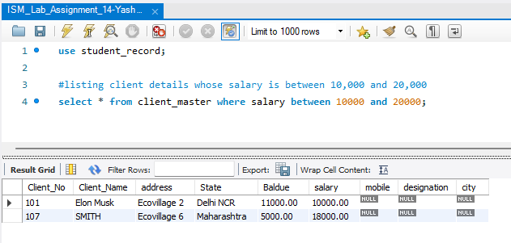

**Task 2: List customers whose names begin with 'S'.**

This task can be completed using the **‘LIKE’** operator, along with the **% (Percentage)** Wildcard Character.

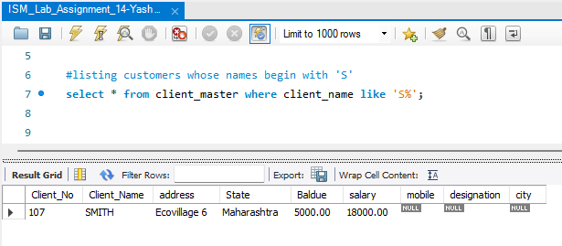

**Task 3: List clients whose name begins with 'el' and are 8-letter word.**

This task can be completed using the **‘LIKE’** operator, along with the **underscore (_)** and the **percentage(%)** wildcard characters.

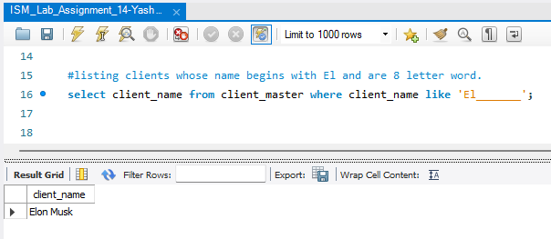

**Task 4: List clients with names SMITH, and ELON MUSK.**

Normally, the following task would be completed using the **Select** command, with the **where** clause and the **OR** operator.

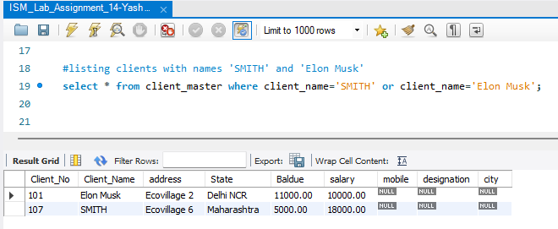

To make this task easier, we use the **‘IN’** operator. To search for a range of values in a data, we use IN and NOT IN predicates, instead of the equal to (=) operator. The syntax for this is -

Select <columnname> from <tablename> where <columnname to be compared> IN(value1, value2, value3, value4......);

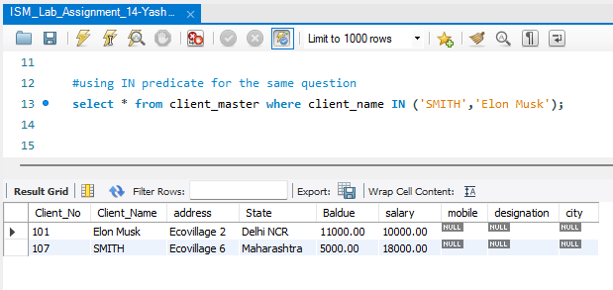

**Task 5: List clients with names other than the 4 names mentioned in Q4.**

Normally, the following task would be completed using the **Select** command, with the **where** clause and the **AND** operator, along with the exclamation mark (!) for the non-equality.

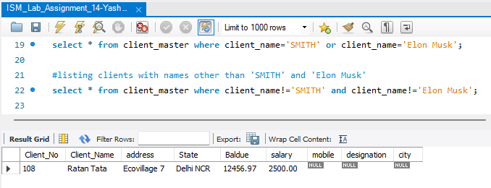

To make this task easier, we use the **‘NOT IN’** operator.

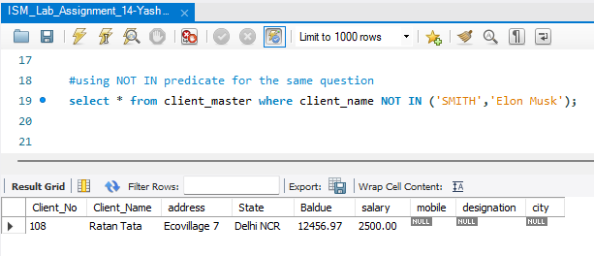

**Task 6: List clients staying in a city starting with 'M'.**

This task can be completed using the **‘LIKE’** operator, along with the **‘%’** (percentage) wildcard character.

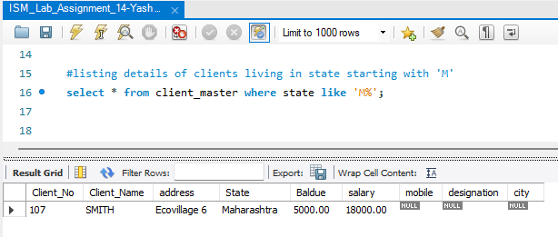

**Task 7: List clients staying in Maharashtra or Delhi NCR.**

This task can be completed using the **‘IN’** operator.

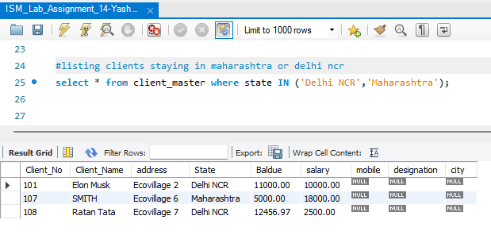

**Task 8: List clients having balance due greater than equal to 12000 or less than equal to 7000.**

This task can be completed using the **‘Select’** command, along with the **‘where’** clause, and the inequality signs <= (less than or equal to), and > (greater than).

